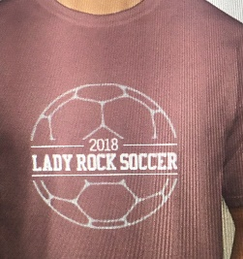
RRHS Lady Dragon Soccer BUDDY SHIRT $20 each
Return Order form and payment to Coach Aldrich by
Friday December 15, 2017
Checks Payable to Lady Dragon Soccer Booster
UP TO 3 NAMES ON SHIRT, LAST NAME ONLY
Player Name______________________________ Player Phone _______________________________

NAME | NAME(S) ON SHIRT  Up To 3 names on back | SIZE  S, M , L, XL,  2XL add $3 | Paid?  Cash/Check

