 | PRICE | S | M | L | XL | XXL | XXXL | TOTAL
PULLOVER  ¼ Zip Graphite Heather  RR Soccer Embroidered Logo | $32 |  |  |  |  | Add $1.50 | Add $1.50
LONG SLEEVE Tee  Maroon with small crest on left chest | $22 |  |  |  |  | Add $1.50 | Add $1.50
SHORT SLEEVE Tee  MAROON  Unisex | $12 |  |  |  |  | Add $1.50 | Add $1.50
SHORT SLEEVE Tee  GREY  Unisex | $12 |  |  |  |  | Add $1.50 | Add $1.50
DRIFIT MENS POLO  MAROON | $25 |  |  |  |  | Add $1.50 | Add $1.50
DRIFIT MENS POLO  GREY | $25 |  |  |  |  | Add $1.50 | Add $1.50
COMFORT RAGLAN  Tshirt Maroon/Grey | $20 |  |  |  |  | Add $1.50 | Add $1.50
LADIES POM POM  Long Sleeve Lady Dragon Soccer across shoulders | $37
HEADBAND  Maroon fleece | $10
TRUCKER CAP  Maroon/White | $12 | ONE SIZE
CAR DECAL | $10 | NAME ON DECAL:
YARD SIGN | $25 | NAME ON SIGN:
Orders due FRIDAY DECEMBER 15
PAYMENT BY CHECK PAYABLE TO LADY DRAGON SOCCER BOOSTER

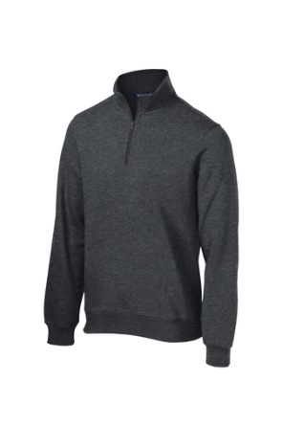
¼ zip heather grey pullover
Dragon Soccer logo
embroidered left chest
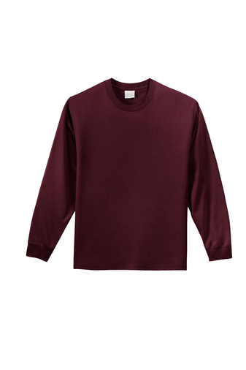_________________________________________________________________
Maroon long sleeve Tee
Lady Dragon Soccer Crest on left chest
Lady Dragon Soccer across back

________________________________________________________________
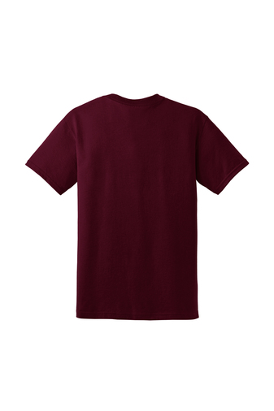Maroon Short Sleeve Tee Unisex
Lady Dragon Soccer Round Rock Tx logo across chest in white

________________________________________________________________
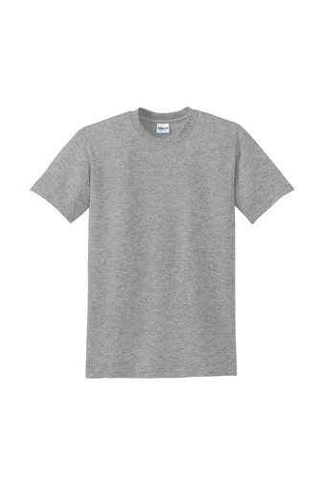
Grey Short Sleeve Tee Unisex
Lady Dragon Soccer Round Rock TX logo across chest in maroon

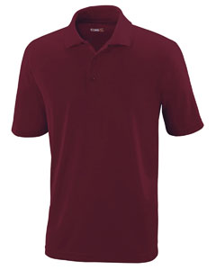
Mens Maroon Drifit Polo
Dragon Soccer logo embroidered left chest

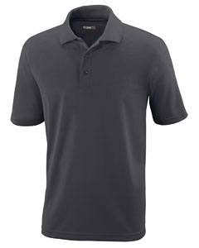Mens Grey Drifit Polo
Dragon Soccer Logo embroidered left chest

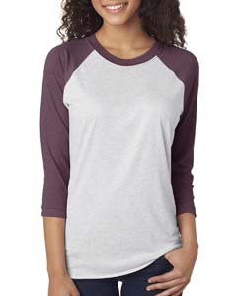Womens Maroon and Grey Comfort Raglan
Dragon Soccer Logo left chest

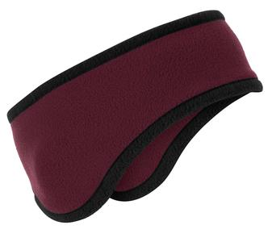Headband/ear warmer
RR on front

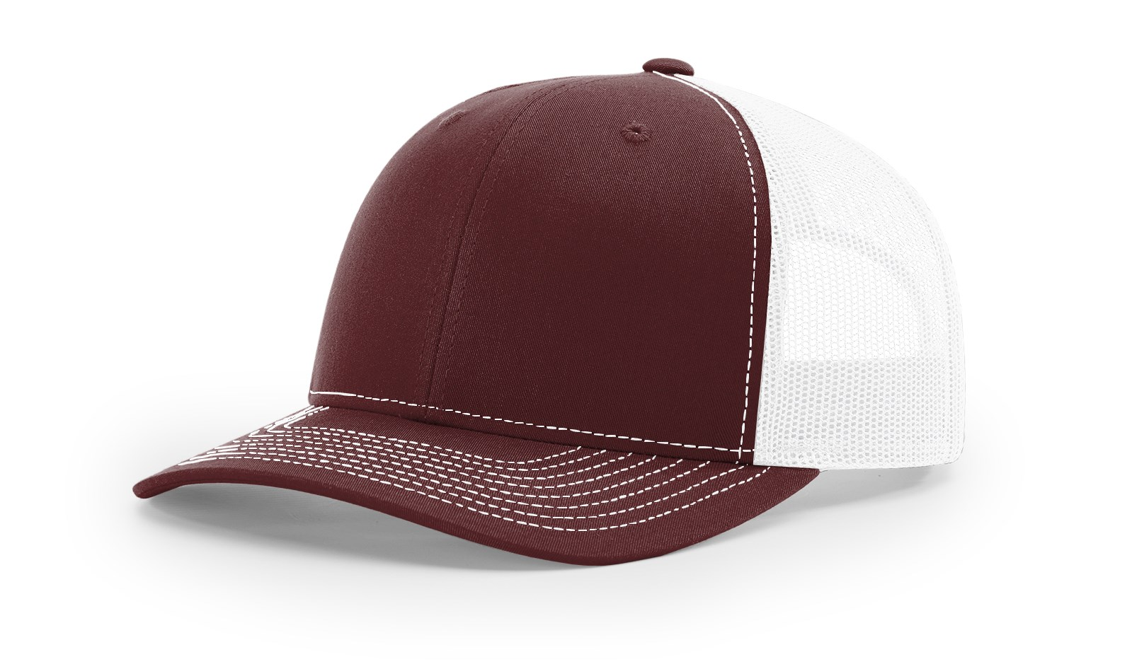Trucker Cap
Dragon Soccer logo embroidered on front

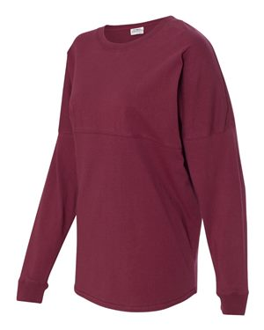Ladies Maroon PomPom
Small RR on left chest, Lady Dragon (chevron print) Soccer across shoulders on back

