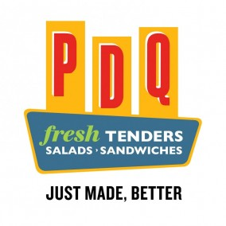
Name_____________________________________

$7.00 Box Meals
Circle your Choices – Choose either the
Sandwich, Tender or Salad Box Meal PDQ302Catering@PDQSouthTexas.com
(Keep choices in one box only) TGonzales@PDQSouthTexas.com
Email with any questions

SANDWICH Box Meals – sandwiches include pickles, lettuce and tomato

- Crispy Chicken or Grilled Chicken or Cucumber Sandwich

- All sandwich veggies or Plain (No Veggies)

- Potato Chips or Apple

- Chocolate chip cookie or Cranapple Oatmeal Cookie

- Mayo or Mustard or Honey Mustard (these will be on the side)

TENDERS Box Meal (grilled tenders, potato chips, ranch and honey mustard are gluten free)

- 3 Crispy Tenders or 3 Grilled Tenders

- Potato Chips or Apple

- Chocolate Chip Cookie or Cranapple Oatmeal Cookie

- Circle your sauce: Ranch or Honey Mustard or Chipotle BBQ

SALAD Box Meal - Dressing options: Ranch, Caesar, Honey Mustard, Blueberry Vinaigrette and Fiesta

Fruit Harvest Salad – Grilled Chicken on Mixed greens, tomatoes, granny smith apples, candied almonds, craisins. Served with Blueberry-Ginger Vinaigrette dressing
Salads come with a choice of cookie: Chocolate Chip or Cranapple Oatmeal

Classic Crispy Salad – Crispy Chicken on Mixed greens, cucumbers, tomatoes and mixed cheese. Served with Honey Mustard dressing
Salads come with a choice of cookie: Chocolate Chip or Cranapple Oatmeal

